CSS Exercise

# The objective

The idea of this exercise is that you learn how to use more advances styling methods in your web site, like position, box-model, display, float, media queries and so on.

# Exercise

Use the mystyle.css file to define the advanced styles in your web page

1. Change the list to be horizontal

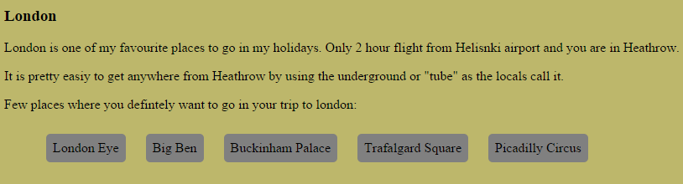

1. Use position method to move the video and the heading text to right up corner of London <section>

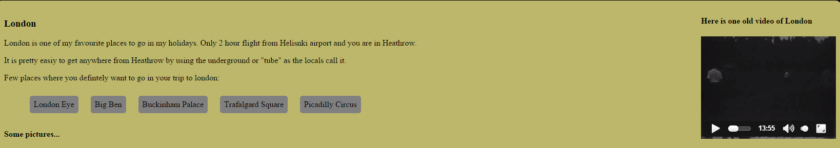

1. Place the image London_vaakuna.jpg with text wrapping using the float property, so that the result looks like this. Note! You have to use the clear property in some element to stop the float!

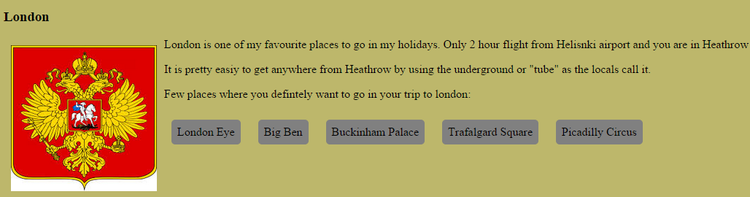

1. Define media queries for display sizes 500px, 1000px and 1400px;